EX NO: 2 | Analysis of SWR (Standing Wave Ratio)Transmission Lines by varying a) load impedance b) characteristic impedance
DATE: 13/10/2026

Test Case 1:
Analyze the SWR of a transmission line for a fixed characteristic impedance (Z_{o}) of 50 ohms, as the load impedance (Z_{L}) is varied across 650 ohms to 850 ohms. Verify how the SWR changes with each value ofZ_{L}. When Z_{L}=Z₀, the SWR should equal 1 (indicating no reflection).
AIM: To analyze the SWR of a transmission line for a fixed characteristic impedance (Zo) of 50 ohms, as the load impedance (ZL) is varied across the following values: 25 ohms, 50 ohms, 75 ohms, and 100 ohms. To verify how the SWR changes with each value of Z_{L} and when Z_{L} =Zo.
SOFTWAREREQUIRED:
SCILABVersion6.1.1
PROCEDURE:
● Open SCILAB software
● Open file-new
● Put the input values
● Typetheprogram
● Execute the program
● End the program
PROGRAM:
clc;clear;close;
Zo=200;
ZR=650-(%i*475);
K=(ZR-Zo)/(ZR+Zo);
ampK=sqrt((real(K)^2)+(imag(K)^2));S=(1+ampK)/(1-ampK);
printf("(c)Standing wave ratio = %f",round(S*1000)/1000);

OUTPUT:
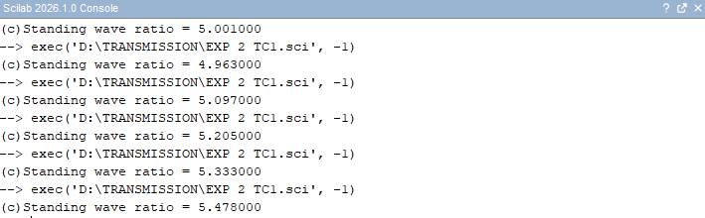
Zo=50 ohms Variable: ZR
ZR Ohms | Simulation Results | Theoretical Results
ZR Ohms | SWR | SWR
450 | 5.001
550 | 4.963
650 | 5.097
700 | 5.205
750 | 5.333
800 | 5.478
RESULT:
The SWR of a transmission line for a fixed characteristic impedance (Zo) of 50 ohms, is analyzed for various values of load impedance ZL. SWR is also examined for the condition Z_{L} =Zo.

Test Case 2:
Analyze the SWR for a fixed load impedance (Z_{L}) of 50 ohms while varying the characteristic impedance (Z₀) of the transmission line to 250 ohms to 400 ohms. Verify how the SWR changes with each value Z₀ including Z₀=Z_{L.}
AIM: To analyze the SWR for a fixed load impedance (Z_{L}) of 75 ohms while varying the characteristic impedance (Z₀) of the transmission line to 25 ohms, 50 ohms, 75 ohms, and 100 ohms. To Verify how the SWR changes with each value Z₀ including Z₀=Z_{L}
SOFTWAREREQUIRED:
SCILAB Version6.1.1
PROCEDURE:
- Open SCILAB software
- Open file-new
- Put the input values
- Type the program
- Execute the program
- End the program
- End the program
PROGRAM:
clc;clear;close;
Zo=200;ZR=650-(%i*475);
K=(ZR-Zo)/(ZR+Zo);
ampK=sqrt((real(K)^2)+(imag(K)^2));S=(1+ampK)/(1-ampK);
printf("(c)Standing wave ratio = %f",round(S*1000)/1000);
OUTPUT:
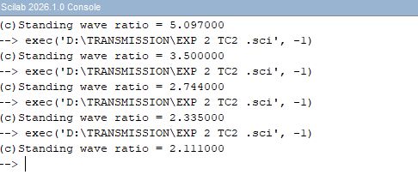

ZR=50/_40º ohms Variable: Zo
Zo Ohms | Simulation Results | Theoretical Results
Zo Ohms | SWR | SWR
200 | 5.09
300 | 3.500
400 | 2.744
500 | 2.335
600 | 2.111

RESULT:
SWR for a fixed load impedance (Z_{L}) of 50 ohms is analyzed while varying the characteristic impedance (Z₀) of the transmission line to 250 ohms to 400 ohms. Impact of the condition Z₀=Z_{L} on SWR is also examined for various values of Z_{0 .}

